Low Level Design Document

**On**

Faculty Skill Enhancement Activity Tracker



VNR Vignana Jyothi Institute of Engineering & Technology Bachupally, Nizampet (S.O), Hyderabad–90

**Submitted By**

**Group Details:**

**Gandham Anudeep - 22071A0519**

**Gujjari Sai Kumar - 22071A0523**

**Vishesh Kondaveeti - 22071A0531**

**Pilli Rushendra - 22071A0550**

**1.Document Overview**

**1.1 Purpose**

The purpose of this document is to outline the comprehensive low-level design for the Faculty Skill Enhancement Activity (FSEA) system. This document serves as a blueprint guiding the development and implementation process, offering detailed descriptions of the system's components and functionalities. Through the utilization of sequence diagrams, the design ensures the seamless execution of the system's functional requirements. This document aims to provide a structured framework for enhancing faculty skills by facilitating efficient management, tracking, and assessment of skill development activities.

**1.2 Audience**

The purpose of this detailed-level design document is to furnish the development team with a comprehensive guide for implementing the functionalities of the Faculty Skill Enhancement Activity (FSEA) system. Additionally, it serves as a means to communicate intricate design elements and considerations to the ITS staff members involved in the project. By providing detailed descriptions of system components and design considerations, along with necessary sequence diagrams, this document aims to facilitate seamless collaboration between development team members and ITS staff, ensuring the successful realization of the FSEA system's objectives.

* GANDHAM ANUDEEP
* GUJJARI SAI KUMAR
* VISHESH KONDAVEETI
* PILLI RUSHENDRA

**1.3 Detailed – Design Process**

Once the high-level design was been completed, we focused on developing a detailed-level design. First a general UML module diagram for the server-side system was generated. Then the team discussed what design patterns could be used to enhance the general design. Then team decided that factory, strategy and command design patterns were appropriate for use indifferent portions of the general design. A more thorough version of the design was generated including the chosen design patterns. Then the team went through each class in the design and decided upon major functions and attributes. Various parameterized objects were added for intersystem communication.

Finally, the team used sequence diagrams to verify that the design is capable of satisfying each use case, as specified in the Software Requirements Specification. The process of generating sequence diagrams lead to discovery of design flaws and modifications to the design were made as needed.

**2.Detailed –Level Design**

**2.1 Usecase Diagram**

**2.2 Class Diagram**

**2.3 Sequence Diagram**

View Dashboard Upload of an Activity

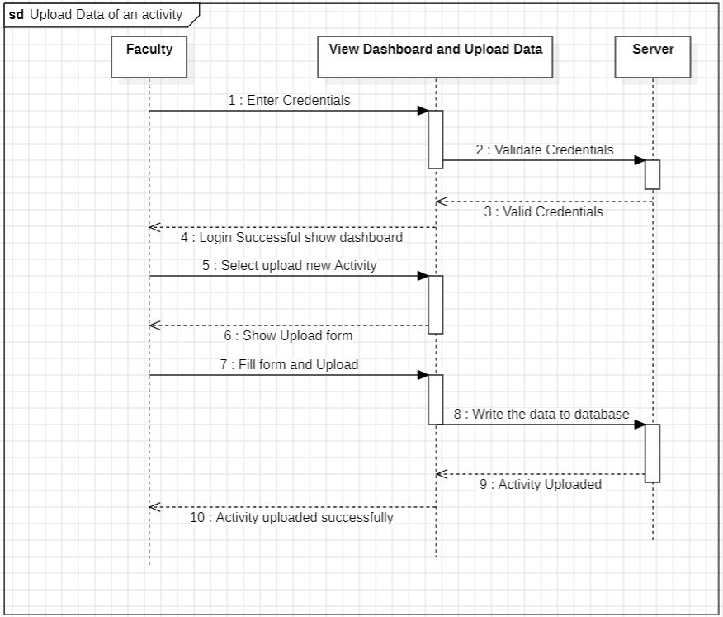

View Activity details and Download certificate of an Activity (Faculty)

View Activity details and Download certificate of an Activity (Admin)

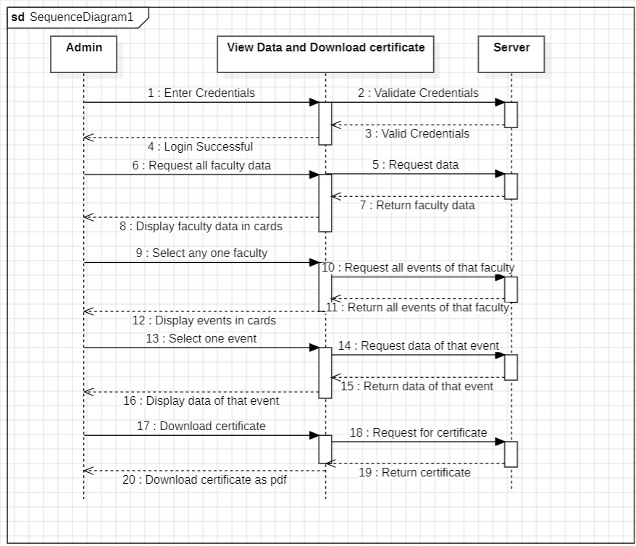

View tabular data and Download tabular data (with/without filters)

**Activity Diagram**

View Dashboard and Upload data of an Activity

View Activity data and Download certificate of an Activity (Faculty or Admin)

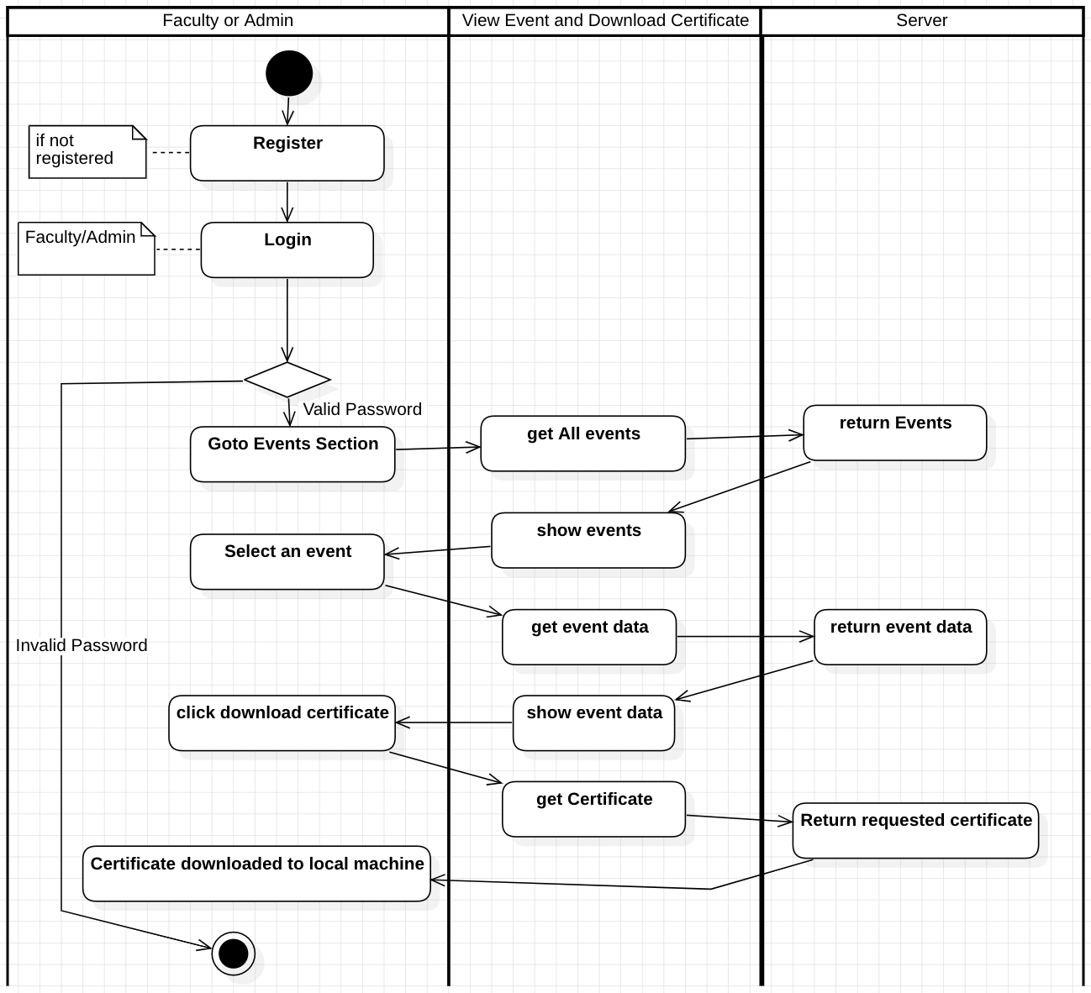

View Tabular data and Download tabular data (with/without filters)

**State Chart Diagram**

Faculty

Admin

**Component Diagram**

**Deployment Diagram**

